**News you can use**

**Heading: Watch out for new ventures by SK Restaurants in India and abroad! (This goes as the subject on mail. No need to include it in the newsletter)**

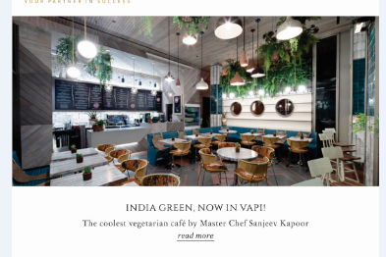

सुनो सुनो! (Hot & Happening – begins with the first large image on top; replace the image accordingly)

**News and Events**

* SK Restaurants celebrated these festivals with complimentary desserts and other exclusive offerings at its various outlets.
* Gudi Padwa and Ugadi – Puran Vada
* Poila Baisakh and other regional New Years – Nikuti Payesh
* Ram Navami – Cocoa Gulkand Gujiya
* Easter – Chocolate Rabdi Doughnut
* Master Chef Sanjeev Kapoor’s Birthday – Malai Pannacotta
* Lok Sabha Elections with a Gulab-e-Gulkand for all those with the inked proof!

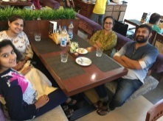 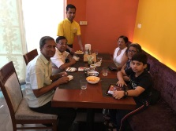   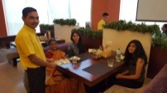

* Chef Sanjeev Kapoor received the ‘Hall of Fame’ Award at the International Hospitality Day Awards 2019 presented by the International Institute of Hotel Management. The event concluded with other stalwarts of the hospitality industry sharing their views and encouraging every hotelier across the world to celebrate their hardwork, passion and dedication towards the hospitality industry.

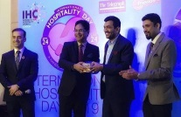

* Of cakes, gifts and lots of food! Master Chef Sanjeev Kapoor’s birthday (April 10) was celebrated at the Head Office with every employee getting a homemade regional dish for him. Chef Sanjeev Kapoor enjoyed every bit of it as he tasted all the lovely food amidst special lines dedicated to him by the employees. Everyone else had fun with his witty one-liners! The day ended with him cutting a specially made cake.

Also, April 22 was our beloved Alyona Kapoor’s birthday which was celebrated in quite an exciting way. Each employee gifted her a rose as she walked down to her cabin. The day concluded with her cutting a special cake made by the in-house chefs.

**Add pictures**

* The season of cricket is here and we can’t keep calm! SK Restaurants has loads of special offerings for all its guests at various outlets – from special menus and live screening to super offers, fun photo booths and much more.

 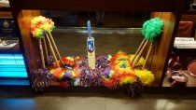 

* The Yellow Chilli, Dadar hosted the event to felicitate the top distributors of Wonderchef. Master Chef Sanjeev Kapoor did the honours amidst the presence of others. The award ceremony was followed by a lunch with a delicious spread of food and beverages.

   

* THE place to be! Laugh, sing, dance, eat, drink with Sura Vie, Belagavi! Your life is sorted at the restaurant with a week filled with events each day. For unlimited fun, here’s what you’ve got:
* Monday – Live Band
* Wednesday, Friday, Saturday, Sunday – DJ Nights with Hemu & Rohit

What’s more?

Enjoy with your tribe with a ‘2+1’ on Imported Beverages.

Winter has finally come! Popular series ‘Game Of Thrones’ is being screened at Sura Vie, Belagavi. Shout out to your buddies and catch the madness alongwith your favourite food and beverage. Make your evenings magical!

* The biggest blockbuster of the year ‘Avengers Endgame’ was celebrated with a special dedication by the team of chefs – the Gauntlet Chocolate Bread. Its fancy, its tasty and its very Thanos. Check out the link for a step-by-step process to create one at home! <https://www.youtube.com/watch?v=-s3ONMutrHA>

Hope you’ve watched the movie by now. If not, watch it today! You cannot miss this cinematic brilliance.

* **Now open**

The Yellow Chilli Express opens its food court outlet at Level 3, Oasis Mall in Dubai. This is the 10th outlet of The Yellow Chilli in UAE.

**Add pictures**

**Watch this space…**

Coming soon!

* 84 cover India Green in Sangli
* 123 cover Signature in Muscat
* 98 cover The Yellow Chilli in Tustin, LA
* 90 cover The Yellow Chilli in New Jersey
* 90 cover India Green at Mira Road, Mumbai
* 104 cover The Yellow Chilli in Nagpur
* 120 cover The Yellow Chilli in Tanzania

**Spotted!**

* World famous Indian gymnast Deepa Karmakar at The Yellow Chilli, Dadar



* Popular Indian rapper Raftaar at Sura Vie, Punjabi Bagh. Did you know his real name is Dilin Nair?



* Indian film actor Advait Dadarkar with his family at The Yellow Chilli, Dadar

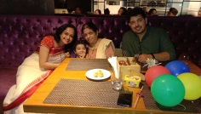

**More awards!**

* The Yellow Chilli, Gorakhpur received recognition by ‘Shaan-e-City by Radio City 91.9 FM for the ‘Dum Biryani’ served at restaurant.

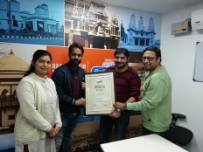

* The Yellow Chilli by Sanjeev Kapoor, Santa Clara got voted as the ‘best’ in the Diner’s Choice 2019 Award by OpenTable.



**Don’t miss this! (Exciting offers – replace first image in the centre)**

Unbelievable, exciting offers!

* Your lunch hours just got more exciting! The Yellow Chilli, Dadar is now serving the ‘Express Lunch’ at the most affordable rate! For further details, call _______. *T&C apply
* It’s raining offers at Sura Vie by tyc, Punjabi Bagh, Delhi

‘Eat and work’ at the Coworking Space. Book your tables today!

Exciting Veg and Non-Veg kitty party packages for all ladies

‘Wine & Dine’ with a 1+1 on all drinks, everyday

Veg and Non-Veg ‘Meal For 2’ packages at pocket-friendly prices

For more details, call __________. *T&C apply

* Enjoy flavours of the north with the ‘Punjabi Food Festival’ at The Yellow Chilli, Varanasi. For further details, call __________________
* Exciting lunch hours with special thali and a complimentary drink at The Yellow Chilli, John’s Creek, GA, USA. For enquiries, call __________ T&C apply
* Make your birthdays and anniversaries super special with exciting offer, complimentary dessert and gifts at The Yellow Chilli, Thane/Dadar. Call __________
* Delectable Indian and World Cuisine at your doorstep! Avail 20% off on Home Deliveries from Sura Vie and Grain Of Salt, Belagavi. For further details, call __________________



**Chef’s Recipe Pick – Soba Noodles in Wild Mushroom Broth (This section needs to be added, missing as of now – replace 2nd image in the centre)**

SK Restaurant’s Executive Chef Abhijeet Kohad, shares his favourite recipe this time – Soba Noodles in Wild Mushroom Broth. He says, ‘Pan Asian food has been a favourite of mine since I was growing up. The rustic ingredients, use of exotic vegetables and simple ways of cooking come together to result in delicate flavours, and that is what the best part of this cuisine is. Not to forget, it is light on stomach and hence keeps the body recharged at all times. One cannot feel stuffed after consuming this kind of food.

Here, this recipe, is my dedication to all things Asian. It is easy to prepare, filling, pretty, full of nutrition, earthy and pretty much comforting. Suits well to the scorching weather as well as you don’t really need anything else after splurging on a bowl full of goodness. Try it to know.’

**Add picture**

***Abhijeet Kohad, Executive Chef, SK Restaurants***

**SOBA NOODLES IN WILD MUSHROOM BROTH**

**Ingredients**

100 grams soba noodles, boiled

1 large carrot, cut into strips

12-16 broccoli florets, blanched

2-3 spring onion with greens, chopped

2 tablespoons chopped and fried garlic

2 tablespoons fried onions

**Broth**

12-16 button mushrooms, sliced

15 grams wood ear mushrooms, chopped

20 grams powdered shiitake mushrooms

200 ml vegetable stock

1½ tablespoons Kikkoman soy sauce

Crushed black peppercorns to taste

Salt to taste

1 teaspoon Togarashi spice mix

**Method**

1. To make the broth, heat oil in a non-stick wok. Add garlic and sauté for a minute. Add button mushrooms and wood ear mushrooms, mix and sauté for 1-2 minutes.
2. Add vegetable stock and stir. Add Kikkoman soy sauce, shiitake powder, crushed peppercorns and salt, mix and bring to a boil. Add Togarashi spice mix and stir.
3. Divide the noodles into individual bowls. Arrange the carrot and broccoli over the noodles.
4. Pour the broth on top, garnish with spring onions, fried garlic and fried onions. Serve hot.

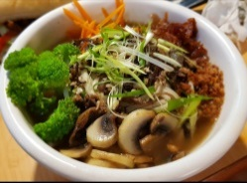

***Soba Noodles in Wild Mushroom Broth***



**Sanjeev Kapoor Diaries (Change Chef’s Travelogue to Chef’s Dairies)**

Master Chef. Globetrotter. Straight from the pages of his diaries!

**Lessons from the past – La Tomatina**

An indispensable ingredient in most kitchens of the world, its origin and acceptance in the kitchen is surrounded by controversy. We are talking about plump juicy bright red tomatoes – read on and find out how these moved from being in an ornamental garden to your plate.

Being considered a vegetable instead of a fruit is not the only misconception surrounding a tomato. It is odd that even though tomatoes were originally from America, they were not consumed there. Tomatoes were initially used as an ornamental plant, because of the pretty red berries on it. Tomatoes were not eaten because people thought they are poisonous. This belief arises from the fact that tomatoes belong to the nightshade family of plants, most of which are indeed venomous in nature. Tomatoes were initially called ‘wolf peach’ for the same reason. The strong nature of odors from the leaves and stems of this plant reinforced this belief. It wasn’t long before people realized that tomatoes are edible and can be used in several ways in the kitchen. By the early 1800’s tomatoes had become an integral part of food cultures all around the world. The popularity of tomatoes increased greatly after the discovery of the pizza and several other dishes from South Europe for which tomato was an essential ingredient. Tomatoes have ever since grown in popularity and are used in millions of recipes worldwide. They are now considered as one of the healthiest fruits – loaded with several beneficial vitamins and minerals that are anything but harmful for you. So, go ahead and add several dimensions to your recipes with this great fruit.

Pro tip: Choose the smaller, flat, thin-skinned tomatoes for making sauces. They will not only give better quality sauce, even the flavour will be better and there will be less residue after straining the puree. You can freeze leftover tomato puree in ice cube trays and use it as and when required.



**Health Bytes (Change Did You Know to Food Facts as the content also has a health angle to it)**

Believe it or not, coconut milk aids in weight loss because of the presence of necessary fatty acids in it. It also helps in hydrating the digestive organs like liver and kidneys.

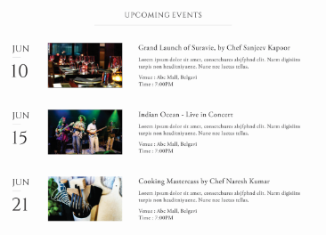

**Partying shots (Partying Shots/Upcoming Events as per the available content. This section needs to be added, missing as of now)**

***  All for a great cause! At the ‘Run 4 Autism’ event by Forum For Autism***

*** Alyona’s Birthday! All set to party!***

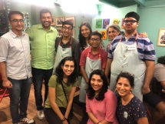 ***With the loveliest lot at Café Arpan – an initiative by the Yash Charitable Trust, that aims to break stereotypes and assist differently-abled people. Know more about this amazing project on my YouTube channel – https://youtu.be/u84Ba6A5i_s***

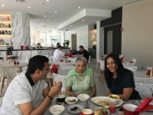 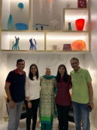 ***#OurAustralianSojourn – With friends and family at The Ruby Collection, Gold Coast***